January 2025

Dear Applicant
Thank you for your interest in the post of Finance Manager at The Spring Arts and Heritage Centre, the “small place where big things happen”.
The Spring is a special place, a unique mix of arts and heritage with Arts Council National Portfolio status. Our aim is to enrich the lives of our community and beyond, in the belief that everyone should easily be able to access the very best cultural experiences.
The Spring is nationally recognised for the quality of the work it produces and the innovative ways it engages with the people of Havant and beyond, whilst being a vibrant, accessible and welcoming community hub throughout the day. We believe that by sharing stories and creating inclusive spaces where anyone can explore cultural experiences, we improve the lives of everyone who engages with us.
We are currently recruiting for an Finance Manager to join our team. The Finance Manager oversees the finance function of both The Spring and its trading subsidiary company Havant Arts Active, providing financial management to the organisation and ensuring it is legally compliant, transparent, and achieving business and financial targets.
Further information about this role can be found in the job description. For an informal discussion about the position, please feel free to call our Executive Director, Fiona Baxter, on 023 9247 2700.
To apply for the position of Finance Manager please complete the Application Form and return it by 10am on 27th January 2025. Applications should be submitted via email to recruitment@thespring.co.uk Interviews will be held on 30th January 2025. Please also complete our anonymous Inclusion and Equality monitoring form which you can access here: https://forms.gle/TqVivXHTG4zcMnWa6
The Spring actively encourages applications from those who are less visible in leadership roles in the arts. We especially welcome applications from women, people with disabilities, those who identify as working class and those from ethnically diverse backgrounds. We are happy to consider flexible working proposals. Please include details in your initial application.
We look forward to receiving your application.
Best Wishes
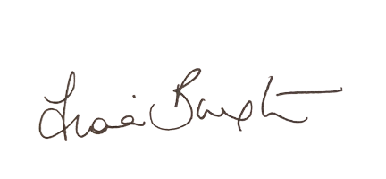
Fiona Baxter
Co-CEO & Executive Director

