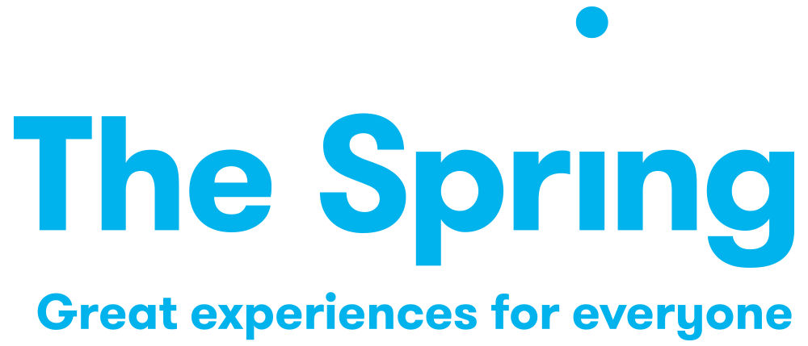

Role Description:
PROJECT PRODUCER – Open Up & Take Over
Revised: March 2025

Timeframe: May/June 2025 – March 2026, approx. 1 day per week.
Given the nature of the project the hours will need to be worked flexibly.
Fee: Freelance - £10,000 – fixed fee
Location: Hybrid working but presence in Havant and Leigh Park will be essential

PURPOSE
To produce a new pilot project – Open Up & Take Over – that will support young people, aged 14-18, to explore creative careers through free workshops, inspiring talks, and cultural trips – experiences they might not otherwise have access to.

RESPONSIBILITES
- Coordinate the project, ensuring aims and milestones of the project are met on time.
- Work to embed youth voice throughout the project.

- Lead on the recruitment and engagement of the young people supported by the Creative Director and project partners.
- Be the lead liaison with the young people throughout the project, coordinating regular meetings and managing their engagement with the project.

- Organise and facilitate a number of visits and live performance trips for the young people.
- Work with the Creative Director to organise, arrange and manage workshops and talks for the young people with artists and others from the live performance sector.
- Work with the Creative Director, Associate Programmer and wider Spring team to support the young people to select, negotiate, market and deliver the live performances.

- Collaborate and liaise with partners in order to deliver project activity.
- Manage the budget for the project supported by the Directors of The Spring.
- Maintain accurate and secure records of participation and engagement data.
- Lead on the evaluation and monitoring of the project, ensuring evaluation methodology is built into the project from the beginning.
- Ensure the necessary and appropriate safeguarding procedures are in place and followed.
- Ensure that the project is inclusive and accessible to all involved.

PERSON SPECIFICATION

ESSENTIAL ATTRIBUTES
- Demonstrable experience of participation and engagement work with young people.

- Experience of working in the cultural sector.

- Strong interpersonal skills – ability to build rapport and trust with participants and stakeholders.

- Excellent communication skills – ability to communicate effectively with diverse audiences, both verbally and in writing.

- Event management skills – experience in planning, organising and delivering events.

- Project management skills – ability to manage projects, budgets and resources effectively.

- A passion for working with young people and communities.

- A knowledge and understanding of policies and legislation related to participation, inclusion and safeguarding.

- An ability to multi-task, work under pressure and be organised.

- An ability to work independently and as part of a team.

- A commitment to The Spring’s mission, core beliefs and a positive attitude and a ‘can do’ flexible approach.

DESIRABLE ATTRIBUTES
- Experience of evaluation and monitoring.
- Experience of working in community contexts.

